# Answers to Questions from P2.1

Name: **Vu Minh Quang**

Student ID: **104184089**

## Is the font type in helloworld2.html similar to helloworld.html (you created in the first week)?

No, it is not similar to helloworld.html (in the first week). Font type in the first week is Times New Roman (default).

**helloworld.html** (week 1)

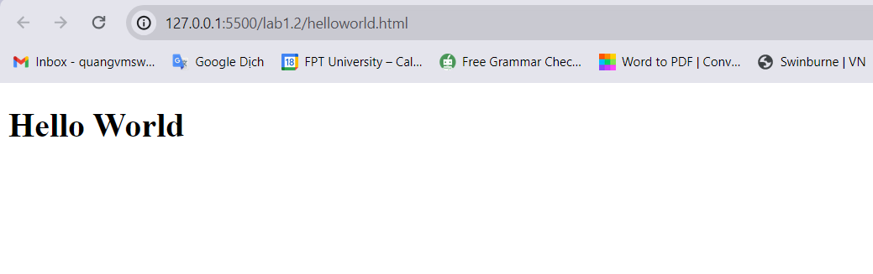

**helloworld2.html** (week 2)

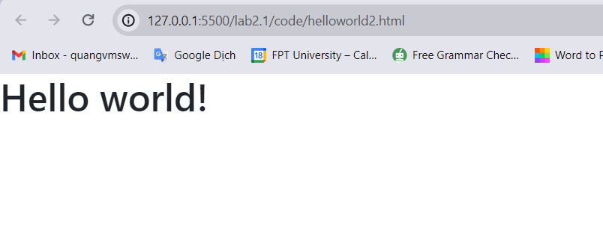

## What happens if you remove <div class="container"></div>?

The information enclosed within the <body> tag will no longer be encased in a container if the <div class="container"> element is removed. Consequently, the content will stretch to fill the viewport and will no longer have the Bootstrap default styling.

The content could look disorganized and might not line correctly on various screen sizes without the container. Changes to the elemental layout and spacing could result in a less aesthetically pleasing and less user-friendly design.

## What is the purpose of <div class="container"></div>?

The Bootstrap framework includes the <div class="container"> element, which is used to create a responsive container for the webpage's content. It aids in correctly centering and aligning the information.